**IREU Advisory Board Member Profile**

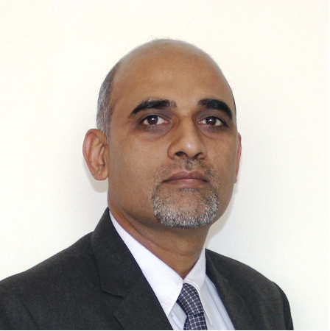

Full Name: Dr. Kamal Kishore Sharma

Present Designation and Company Name:

1. Professor & Head of International Centre for Excellence on Surface and Air Transport (CSAT)

Adani Institute of Infrastructure (AII)

1. Director at Multiple Startups

Total Years of Experience: 31

Areas of Expertise: General Management, Leadership Development, Entrepreneurship, Logistics

Summary of Contributions in your area of work (Minimum 6 Lines).

Dr. Kamal Kishore Sharma is an MBA and Fellow (PhD) of IIM Ahmedabad. In a rich corporate career spanning three decades, he joined a PSU (SAIL) as a Management Trainee and later the prestigious Indian Civil Services (IRTS). Soon after PhD, he joined the global leadership team of ArcelorMittal where he rose to be the MD & CEO at a Kazakh subsidiary at a young age of 39. At the turn of the 21st century, he was in the founding team setting up the Adani Institute of Infrastructure Management (AIIM) and also led the Ansal University Gurgaon as a Dean & Vice Chancellor. At AII, he currently heads the CSAT, a CXO trainer and visits IIMs as a Leadership & Industry Expert. Dr. Sharma is passionate about social entrepreneurship and in the last 5 years has been part of the founding teams or nurtured more than 10 startups in domain of agriculture, water & education. He is a well regarded speaker, coach, mentor & motivator.

Quote on IREU Real Estate Education Private Limited:

There is a great scarcity of an organized information amidst a deluge of knowledge around. Can IREU REE turn the tide and spread the light?